1 So you want to own a lifestyle block? 3
1.1 Introduction – getting started 3
What does your dream look like? 3
Caution – be aware! 3
Location- North, South, East or West? 4
Size 5
Topography and micro-climate 6
1.2 Buying? 6
1.3 Get serious about costs! 6
1.4 Building on your block/Getting started with a bare block. 7
Environmental constraints 7
Topography 7
Summer vs Winter 8
Existing plantings 8
New plantings? 8
House 8
Indoor outdoor flow 9
The back door/porch area- Rain and Flies 9
Car park and turning with trailers 9
Storing the big stuff? 9
Yards 9
Barn/Shed/Workshop 10
Fires and damage 10
Firewood 10
Poultry 10
1.5 So you’ve just bought an existing block? 10
1.6 Thoughts about neighbourliness 11
1.7 Doing it right first time 11
2 Health and Safety 12
2.1 Risk Assessment and Management 12
Identify the hazards 13
Analyse the risk 13
Minimising risks - control the hazard 13
2.2 Managing Contractors and PAYE employees on your block 15
3 Keeping safe with equipment 16
3.1 Three keys to Tractor Safety 16
Tractors – very useful, potentially very dangerous. 16
3.2 Basic rules of tractor safety 17
3.3 Quad bikes 18
3.4 Chainsaws 19
4 Soil Management 19
4.1 19
4.2 Compost – keeping it simple 19
5 Poultry – Chicken Raising 20
5.1 Getting purpose sorted 20
5.2 A word or two about ‘free range’ 21
5.3 Suggestions 21
5.4 Must have 21
5.5 Killing and Meat? 21
6 Deleted. 22
A word about purpose 22

Soil and poultry hardly started as you can see.

The table of contents isn’t working properly either… but that is for later.

So you want to own a lifestyle block?

Introduction – getting started
I remember the day the block we wanted become ours. I walked around looking at lots of broom and gorse and thought – oh my goodness, this is all ours! We can manage this just as we wish. We don’t have to worry about what anyone else thinks or says! This was full of promise and we could put our stamp on the land, while accepting some things would never change – broom and gorse will be here, long after we have gone! We called it Ballybroom, to honour the Irish and the main ‘crop’! It was ours. There’s magic in there!
Your planned block may be big, small or tiny. This chapter is for you! You may have just purchased a block or possibly owned it for some time. The earlier you start in getting key decisions right will pay big dividends. Many of the decisions you make will both give you options, while also reducing those options. Choosing location does that rather quickly!
We’ll take you through some key areas with bullet point checklists. But before we get there – remember life is made of many compromises mixed with the opportunities. The perfect block may exist, but your team of authors haven’t found it yet! So use the checklists as a guide to the decisions you make. We can ask the questions. Only you can weigh up the importance of each. Remember, compromise and opportunity.

What does your dream look like?
Think about, read and we suggest - discuss with close family members and friends - your purpose in becoming a block holder/small farmer. Define it how you wish – call this vision or purpose or just the reasons for owning a small block – your answers will establish how you spend much of your time and money into the future. Purpose will be clarified as you read, discuss, dream with key family members/friends. The questions below are actually designed to help you define your purpose. Getting it right is really important. Now is a really good time to learn to listen – really listen to others involved – spouse and children especially. If this is your dream only, will resentment build?
It isn’t hard for a small block to rule your life and cheque book – especially so if you add animals of various kinds. That may be exactly as you wish… but if the time and money for holidays and long distance travel are primary desires – well, think carefully about the choices, opportunities and restrictions involved in being a small holder. There’s responsibility here too – particularly relating to animal welfare. So here are some questions. The way you deal with these questions is up to you. That’s the wonder of a small block. It’s yours and you get – normally as a family – to set your priorities. Well mostly! There’s those cheque book issues… that are likely to constrain you.

Caution – be aware!
There’s much to celebrate in block holding. But if this is your first foray down this path, consider why so many block holders quit after a few years. What went wrong with their dream? Each of the aspects of block ownership are demanding – often in terms of
- animal welfare, (fencing, feed and care required 24/7 in nice AND awful weather),
- Travel- it is not hard to find yourself a long way from services like supermarket, garage, sports field etc,
- Maintenance – that lovely big lawn the landscape architect was so enthusiastic about, along with all those gardens… take a lot of time to keep looking presentable,
- Blocks take a whole lot more money than people realise – mortgage, specialist tools (aka boys toys) that need buying then maintaining and running,
- and more. Talk with those who have experienced the life style. Are there shared options that would work – a hut on the back of someone else’s property?
- A final statement – if you have never done this before – it is a wonderful journey but will be more demanding of your time than you ever realised. This may be especially the case for those who choose to go fully organic – replacing chemical solutions for often more labour intensive ones. Where is the willing Woofer?
- Still with us? Read on and enjoy!

Location- North, South, East or West?
It is time to consider location in terms of the broadest picture of New Zealand’s opportunities. As you know, North and South tend to define temperature. If you really want avocado’s then don’t come too far South. If cherries spin your wheels and taste buds, then Northland may not suit! If lots of hot dry wind isn’t your cup of tea, East may not suit. Going west normally means higher rainfall and fewer drying North-Westerly winds. Having lived in both islands there is no doubt that if you hate insect pests, snails etc – a move south will significantly reduce those challenges. Frosts kill a lot of plants, but they sure reduce insect problems.
Your location questions are answered when you are clear about your purpose as discussed above and through all the questions in this section. You need to go and visit the area, not just the property that is for sale. Talk to others. Finally as you settle on a block or two of interest – make sure you talk to prospective neighbours – getting a feel for the pro’s and con’s of the area. The decision you make relating to location will be one of the larger decisions you make in your life.
- Will the new block require a shift – with consequences for family and life-long friendships?
- Is your preferred site one that will allow you to successfully grow your chosen crops or livestock?
- How important is access to town/city for sport, shops, medical care and recreation? Each of us will answer this differently.
- How much travel will be required each week for off-block work? There’s time, cost and maybe even safety to consider. Vehicles cost lots more than fuel to run!
- Getting any trades person to your block, including items like concrete gets exceedingly expensive in those wonderful, truly remote parts of New Zealand.
- Will the move to a block require a new/different style of vehicle to be purchased?
- Year round access may be really important for your primary income earner and/or access to school. Think distance, floods and snow. Our road is presently disappearing under snow, so only the 4WD we bought after purchasing the block will get us out soon.
- Who else shares the road? Large logging trucks may not bother some, but they may bother you on pick-up and drop-offs to school…
- Being close to a shingle/gravel road may mean your house is covered in dust each time a vehicle drives by! Where’s the prevailing wind? The days when a dose of old engine oil on the road to settle dust are long gone.
- Is the road publically owned but privately maintained? Ours is. Other users may be unwilling to help with maintenance costs. When access tracks are wet and used by fast moving trucks, it is really surprising how much damage occurs in just one week.
- Location will dictate market access and the costs associated with marketing. If you are keen to sell fresh produce this may be a critical issue. A once a year harvest of nuts changes requirements location wise as sale time and number of sales in a year are very different to the fresh market scene.
- A lot of blocks also have bed and breakfast or other accommodation options. Location can make or break this option. Some consents require neighbours approval.
- Can you market your saleable products in ways that don’t kill the profit margin? It is hard to grow and sell on better than peasant wages when operating on a small scale. Go on, prove me wrong!! We are fortunate in that most paid work comes from home based office so there are no travel costs. Gardens, orchard and livestock can then be a source of pleasure and heaps of food to enjoy and often give away.
- History of site – if you want to be registered organic some areas have a history of using long lasting chemicals that stop your organic registration – perhaps for many years.
- While thinking chemicals – remember that toxic chemicals do two key things. They save labour, allowing our supermarkets to be filled with cheap fruit and vegetables. If you disagree with the word cheap – try growing those same crops and pay yourself a nominal $25/hour for each hour spent growing…! Those chemicals allow a form of perfection to be presented – but discussing chemicals with a commercial grower of broccoli and brussel sprouts – he was surprised at how many toxic chemicals are required to meet the standard market requirements. If your chosen crops really require lots of spray and you dislike spray – you have some new thinking to do! Recently I bought a cauliflower from the supermarket and decided I know why I prefer ours! The background chemical taint/flavour did not sit well with my taste buds. It had grown through late Summer / Autumn - a period of intense spraying due to white butterfly and aphid flights. When grown in Winter / early Spring cauli’s need almost no spray and the organic flavour shines in our home grown vegetables.
- Soil type? You may need expert advice and locals will be very helpful. Think about water holding capacity, winter pugging, pH, fertiliser requirements and costs of application. What is the history of the block? Has it been hammered by commercial market gardening with a reliance of chemical and cultivation to the extent that most organic matter in the soil is long gone? We cover more detail on soils later??
- Water supply? This can be a very big topic. It starts with what water is needed for and how much is available. Think about home, trees, livestock, fire protection/fighting. Are consents required? What is the reliability of the spring/well and are their water quality/taint issues to consider?
- Tools for the lifestyle/Training – eg use of chainsaws, forestry ladders/tree felling… Safety and costs and maintenance…
- Tax issues – business.
- Fencing – for various classes of stock. Electric fencing… pros and cons. Remember that in snow fences short out and stock may wander in a dangerous manner.
- The tie to livestock – during summer holidays and right throughout the year. This may help explain why blocks change hands every 7 years or so…
- Vegetables and shelter / competition with shelter trees – plan shelter carefully.

Size
- Too small and you can’t do what you want, and neighbours requirements bite- because they are shaded by your favourite large trees – that keep getting larger.
- Too large and the mortgage/rates/insurance bill kills you. Or the maintenance of fences, weeds, pasture, become overwhelming.

Topography and micro-climate
- Do get expert advice. Others will see things you don’t see. In most locations there are subtle differences in soil type and depth, in temperature / frost hollows, sunshine and wind protection that will make a long lasting and large difference to the plants you grow.
- Remember there are many ways that we can act to modify the challenges. Shelter trees or windbreak cloth and glass-houses are two obvious ways we can cope with the harshness of a cold or exposed site, while enjoying stunning views!

Buying?
- Neighbourhood? Talk to the neighbours and other locals. Don’t just take the word of the seller/agent. There may be flood, wind, drought, snow issues to consider (Canterbury earthquakes have taught us the importance of liquefaction).
- Trademe allows buyers and sellers to get together and make agreements. We settled a price recently through Trademe. It was fantastic. But, we didn’t make the mistake of believing we only needed buyer and seller involved.
- Quickly ensure that both parties put the deal in hands of the legal profession – get a quote first. Then sit back and allow the professionals to do what they do best – protect all parties and ensure the best of outcomes. No surprises is good at this stage.

Get serious about costs!
Having just stopped outside a real estate agent’s office I’m stunned by how much bare blocks cost!
As I write, it’s early morning and the rain is pouring down in Central Canterbury. Our 10 ha (25 acre) block has 7 ha that is thoroughly susceptible to flooding. Money ear marked for other purposes may well be used by a 25 tonne digger to dig in more poles of willow and poplar for river control purposes. Talk about a sink hole for money!
But that same river is part of the joy of owning this block. It’s rough and river bed. There’s wild life abounding. It is close – really close to nature and you can get lost in gorse and broom and forestry. I love it!
Building costs keep climbing and there are many costs that can be under-estimated when starting with a bare block. It seems the Canterbury earthquakes have frightened a lot of councils. Foundations particularly have become much more expensive and all building costs have risen considerably. Here’s some other costs/issues to keep in mind.
- Planning and consent.
- Architect and travel for everyone needed on site. There’s that travel cost again!
- Covenants may be severely restrictive. If you are a free spirit, you may want to buy in a more remote site – where covenants will be much less restrictive. If you are buying in an area close to a main town/city, with many neighbours on small blocks you may well find there’s rules – no pigs, no roosters, no two storey dwellings, no… and the list goes on. Check carefully.
- Power in some sites is a very expensive issue. Even the consents to go it alone with wind generator, solar panels/batteries and generator backup can add considerably to cost. Check these out before you make a final decision. Friends were going to be hit thousands of dollars just for consents to put in wind power etc.
- Phones – is there good land-line or cell phone coverage? Technology is changing rapidly meaning old rules may not apply!
- Sewerage and what is known as an outflow field – think $15-20,000 all up.
- It is easy to under-estimate all the ‘little’ costs – things like paths, clothesline, BBQ area, orchard, woodshed. The view that is wonderful may require short term wind-break cloth to allow plants to establish well. There’s cost and compromise in managing wind.
- Live shelter including ripping to allow root growth and long term tree stability, pre-plant weed control and adequate stock proof fencing and irrigation make for significant cost.
- Landscape plants – whether large or small, are costly, especially if you have been watching grand designs and have grand land-scaping plans!
- Do you want a large, regularly mowed lawn? If so, think costs of ride-on mower and fuel, time and sustainability. You may be able to reduce the amount of mowing by protecting some special trees and letting stock do at least some of the grass control. We live with a laissez fare style, allowing wild vipers bugloss to grow through an area of olives and other landscape trees. The downside? Fire risk with lots of dry grass. The answer – keep the grass mown short within 10 m of the house accepting increased fire risk away from the house.
- Easements/paper roads on the title which will allow others right of access?
- What consent issues may be a problem? Sewerage, height restrictions, neighbours who can operate noisy dusty polluting… eg spraying for hort crops and spray drift, helicopter noise keeping frost off neighbours grapes etc… Some districts don’t allow tree planting on some blocks for forestry purposes – by way of keeping water flowing into dry watersheds!

Building on your block/Getting started with a bare block.
What a fantastic opportunity! It is all in front of you. Siting each component of the block is open to you. Of course there will be factors that limit your decisions. Here are some of the items to consider.

Environmental constraints
- There are many requirements that may surprise you relating to block holding.
- Be careful. It may feel isolated but there are many eyes in the country and it pays to do the right things. One learns by reading and listening to neighbours and others – laws are in place to assist the whole of society do well together.

Topography
- You need to know where the sun will be at various times of the day and year. Take advice if this isn’t clear.
- There’s view, drainage, wind, sunshine to take into consideration. That long steep drive in summer may be fine, but winter may require very expensive inputs to keep it providing access.
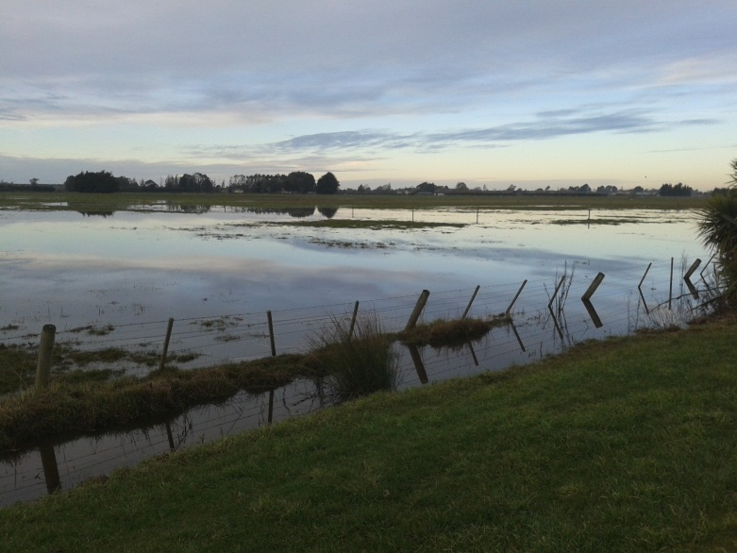
Summer dry turns to only good for ducks… in winter – ask neighbours for the important features of your desired block.

Summer vs Winter
- Winter rain can form large puddles (or worse) at the back door. Think really wet and ensure that key elements are well above flood zone. No surprises on this score is good!
- Ensure drainage for flood/puddles.

Existing plantings
- Put the chainsaw away! Don’t rush to knock over existing trees – until you have experienced something of storm wind and summer sun – right when you have friends for a great BBQ and have a new sense of how challenging your environment can be.

New plantings?
- Of course you are going to look around at what grows well in your district.
- Take note during different seasons.
- Talk to neighbours and nurseries – people with local experience and passion are the people to talk to. Some of them will have cuttings and plants to help you.
- Do you have a theme? Eg natives and will they be only sourced from plants that are genetically “local?’ These are choices you will make.
- Remember that shelter trees that grow quickly, do so because they are very good at grabbing nutrients and water. They will reduce the growth of those special, high value trees you really want.

House
- Aspect – facing the house towards views/sun, away from driving rain and drizzle
- Access – cost of drive and turning/parking area. Make this large enough – you will want some celebratory parties! Our party time is the Autumn celebration of God’s goodness in the harvest. Masses of corn, and fresh tomato, basil and mozzarella cheese in the home made pizza oven. And/or masses of potato and pumpkin wedges – again in the pizza oven, or fresh wild pork bedded down in heaps of watercress from the neighbour’s creek.
- Views – wind protection and view tend to be a case of ‘you can have one but not both!’ We choose to plant just deciduous trees to our view and main wind. That way we get snowy mountain views through the bare winter branches of poplar, alder, ash, liquid amber, willow, oak, cherry and silver birch. Some of the willows are basket willow, with amazing colour black/silver and gold/red winter bark. Natives dominate towards the south and our wet cold winter winds. We’ll discuss this in more detail under landscaping decisions.
- Think neighbours – will their trees ruin your plans? Will your trees ruin theirs. Are their compromises that work?

Indoor outdoor flow
- There’s a trend right across New Zealand towards really large homes, with really expensive price tags. The cost is not only in the mortgage, but also in the money available to generate fantastic indoor/outdoor flow. Bigger homes means more carpet, more windows to clean and less money for all the projects that require funds outside. Keep a balance between house size and price and the special items that make a rural environment so special. I’m thinking of deck/terrace, pergola, pizza oven, outdoor kitchen, etc.
- Water and power, with a roof for rain over the pizza oven, bbq area is a must have in my world.
- Have a long term plan in mind. You won’t achieve everything straight away, but at least one sheltered area, that provides a great place to sit and enjoy friends over, outside, is a must have in my world.

The back door/porch area- Rain and Flies
- Every rural house needs a sheltered, dry area to take off boots and dusty/dirty overalls. Our biggest mistake has been to have a back door that gets rain blowing into it, even though it has a 3 m overhang of carport. Means socks get awful wet if you take boots off in our porch area. Not great!
- Somewhere to sit to put on boots is really useful! Maybe a hinged lid to hide spare boots for when the cousins come visiting.
- Think fly screens and the way a double door may work – the security door and the fly screen.

Car park and turning with trailers
- Friends need somewhere to park and get inside without getting too wet or muddy.
- Can you bring a truck load or trailer load of firewood in and out, easily?
- Can you design things so there is a round about feel, to reduce the need for backing.

Storing the big stuff?
- Most block holders like having a good trailer and sometimes more – boat, tractor, spare old vehicle, mower etc.
- Providing a sheltered space is going to pay dividends.
- Gear stored for ages will be damaged by rats and birds do know that tractors make great nesting sites – with fire damage quite possible. Check before starting.

Yards
- Drenching, shearing, foot/hoof trimming, weather, shade, rain.
- Cattle or sheep or both?
- Other specific requirements for certain species?
- Shearing for alpacas requires a large mobile swinging table – have you room, under cover?
- Anyone owning livestock has to have TB tests and NAIT (refer??). This means restraining the animals in a secure set of yards, with – for cattle at least – a neck crush to hold the animal in one place without endangering the people working with the animal.
- Can you turn a large stock truck around – without it getting bogged? Year round? There’s a challenge for most block holders! Some yards are set up so that the truck turns around down the road and is able to simply back up to a set of yards with a loading ramp sited for easy loading.

Barn/Shed/Workshop
- We started with one four bay barn existing on our almost bare land block and quickly filled one bay with young calves being reared. But the barn was in the service area of the property and so had no good grass pasture for the calves to move onto. That bay is now full of timber. We didn’t really want the bay full of straw and manure.
- We’ve since built a second barn in a paddock, making one wall of the barn provide the side of a small (tiny actually) set of yards for cattle, goats and sheep. That barn provides a bay for hay and a second bay for weather protection for goats that hate really cold and wet conditions. It is sometimes used for calf rearing and is close to the house, but hidden from view. It faces north with a row of cabbage trees behind. Trouble is it is on top of some precious good soil! There’s always compromises with each decision made! In time that bay could be a suitable stable for a horse, given it’s proximity to the home.

Fires and damage
- We learned early that in the event of a disastrous fire starting, we would be on our own for at least 20 minutes. In that time, a fire could have got a substantial and extremely damaging hold on our property.
- For that reason we have a large (13,000 litre) tank with a 50 mm gate valve that fire service can click into. Getting the right fitting is worth doing – before it is needed. Check with your local fire service. They like the sense of being prepared and are bound to be helpful.
- Some species are known to be serious fire hazards – give yourself some space between these and your buildings – eg cabbage trees (leaves fall in abundance), kanuka/manuka, eucalypts of all sorts.

Firewood
- Firewood is another matter for most New Zealand block holders. Having enough wood dry for this winter and most of next winter’s drying under cover is wonderfully pleasing.
- Will you be able to carry wood from shed to fire with clean feet and arms that are not too tired?

Poultry
- Most lifestylers want at the very least some chickens. There’s free range, flies and ease of access to consider. Hens are really destructive, so a fence and gate are pretty important.
- Can you get to the hen run without getting really muddy? If you live on a slope, will you need skiing skills after rain. Blocks tend to look and feel very different between summer and winter.
- Somewhere to store feed out of the rain and sun.

So you’ve just bought an existing block?
Some thoughts for you.
- Don’t rush to cut down existing trees until you have experienced a year of wind, sun and rain.
- If you haven’t been to say hello to neighbours – now is the time. In a town environment you may have been able to ignore neighbours, but a good part of the richness of life in a rural setting is the quality of good neighbourly relationships. There’s sharing of tools and larger ‘boys toys’ – tractors and the items that get put on the back – mowers, cultivation equipment, post drivers etc. Normally for the small holder these privileges come through our helpfulness with casual labour.
- Neighbours are likely to have useful background that wasn’t apparent earlier in the discussions. Maybe you are wishing you had talked with them earlier!

Thoughts about neighbourliness
Our block has a river boundary for about 1 km. When we try to manage river erosion it isn’t hard for our actions to have a negative impact on the neighbours over the river… We manage that issue by neighbours working together to plant Environment Canterbury supplied poles in agreed rows. That way there are no nasty surprises. We enjoy the working together. It is a big part of the richness of living as neighbours and friends.
Here are some suggestions that could be called – rules for being a great neighbour. Firstly though, there is a reality worth noting. The smaller your block and the smaller the blocks around you, the more care is required with neighbourliness. On really small blocks your actions can have a devastating impact on your neighbours. That large evergreen (macrocarpa, pine etc) that is getting ever larger, sheltering you from southerly winds is the same tree that steals most of the winter sun of your neighbours. You may need to put yourself in their shoes when considering a request from them for pruning or removal.
Here’s the suggested rules
- Establishing neighbourliness takes time and trust is built slowly.
- Trust can be ruined with one outburst or one mistake. Take care.
- Don’t take the relationship for granted.
- Don’t take access for granted. Ask, and establish agreed ground rules.
- Be helpful, before you need the neighbours to get you out of a mess!
- Discuss plans where your actions will impinge on others enjoyment of their block.
- There are some weeds that blow in wind. Don’t allow your property to become the seeding ground for problems you share freely with your neighbours.
- Finally – treat others as you would have them treat you. Isn’t that a golden rule?
- If you like things in 10’s …
- you can add the last two.

Doing it right first time
It’s probably a case of do as I say, not as I do! I could give a few examples, but I’ll let you figure for yourself. There’s many times when the competing demands of fencing, building, landscaping, animal feeding and maintenance all mean that a job is done in a rush.
It’s so much better and more pleasing in the long run, when a job is done really well and to a high standard. That way the fence stays tight, because the stays are well made and the fence doesn’t short out, the hen run stands up to the wind, the door works well for years and rats don’t get to feed happily on expensive pellets etc etc.
Do as I say, not as I do, and you’ll do well.

Health and Safety
The general duties of employers under the Health and Safety in Employment Act 1992 are to take all practicable steps to:
- Provide and maintain a safe working environment;
- Include employees in the development of health and safety procedures;
- Identify hazards and apply practical controls to significant hazards (see also section 1.14, Hazard identification and control);
- Provide and maintain facilities for the safety and health of employees;
- Ensure that any machinery or plant that employees use is safe;
- Ensure that any processes that employees are involved in will not adversely affect their health or safety;
- Provide employees with information on workplace hazards, and ensure that employees are trained and supervised;
- Record and investigate workplace accidents and illness, and report any that constitute serious harm; and
- Develop procedures to deal with emergencies which may arise at work.
This is the kind of topic most of us want to cruise past, hoping it never applies to us. It does. As block owners we are responsible in ways most of us do not realise – for our safety and the safety of those who come anywhere near the block. Even casual visitors are part of our responsibility. We can be held liable if we’ve been slack with regards to health and safety – so bear with us as we take you through the key issues. There is much more legal detail and plenty of useful advice at http://www.business.govt.nz/laws-and-regulations/health-safety.
Most of us hope that if we use a contractor we are exempt from responsibility for their safety. Not so. You are responsible for the health and safety of all those working on your land whether PAYE or not.
The Health and Safety in Employment Act 1992 requires that rural places of work should, as far as is practicable, be healthy and safe for everyone in them. A quick review of the literature confirms what most of us know – there’s lots of rules and expectations on us as owners. Hiding our heads in the sand and hoping for the best isn’t good enough. Occupational Health and Safety have some very serious sticks with which to encourage right practise right across the agricultural industry. Block holders are not exempt.

Risk Assessment and Management
Risk Assessment and management will help all those on your land stay safe and healthy. There are three key steps and the Deer Industries web site summarises them at www.deernz.org.
- Identify the hazards
- Analyse the risk
- Control the hazard

Identify the hazards
You need to have an effective method for identifying existing and new hazard situations, and for regularly reassessing the hazards identified. When thinking about hazards, consider the equipment or situations that could pose a risk to yourself, your workers or others.
Hazards may include:
- Land and infrastructure (bridges, culverts, cattle grids, muddy ground, streams)
- Machinery e.g. chainsaws, brush cutters- and lack of familiarity with appropriate/safe use
- Farm vehicles e.g. tractors, quad bikes
- Product or commodity storage systems (e.g. silos, slurry pits, feeding pits)
- Workshop tools and equipment (e.g. welding apparatus)
- Animals – just because you hand reared the bull calf, doesn’t make him predictable and placid at all times
- Races and yards
- Chemicals
- Manual handling or lifting (e.g. building, fencing)
- Power sources e.g. gas, electricity
- General hazards (e.g. slippery stairs, ladders, tools)
- Noise (e.g. shearing sheds, chainsawing, tree felling)
- Diseases passed from animals to humans (e.g. leptospirosis)
- Skin cancer
Lifestylers may add another hazard, somewhat unique to our situation. We are less familiar with tools and tasks than our full-time cousins down the road. We often have other jobs that means we may be in a rush, into a dark evening trying to get a particular task completed. We have to keep health and safety in mind, so that we get to do the good stuff tomorrow, along with those working and playing with us.

Analyse the risk
Having identified the equipment or situations which may pose a risk, we need to assess that risk according to its possible severity in terms of life, suffering and dollars. The risk analysis could be based on any one or more of the following factors:
- Have there been accidents with this task in the past?
- How important is this - Maximum potential loss (human and money)?
- How likely is it to happen again?
- How many people are likely to be involved?
- Perceived severity of new accident
- Newness of the job for you or your employee.
Discuss with family members and employees the risks associated with the lifestyle block. Ensure they also take safety seriously.

Minimising risks - control the hazard
Once the hazard has been identified and the risk assessed, control measures should be used to reduce the risks of an accident. These include:
- Eliminating the hazard at source
- Reducing the hazard at source
- Reducing the employee’s exposure to the hazard
- Removing the employee from the hazard
- Containing the hazard by enclosure or isolation
- Supplying and using personal protective equipment
- Training workers about safe work practices
These topics are explained below.

Avoid hazards wherever possible
It’s always better, if possible, to avoid the hazard altogether through the design of equipment, substitution of hazardous substances, alternative systems of work and so on, rather than to rely on control measures such as use of personal protective equipment. Talk to other employers, employees, etc. This can help you identify and resolve problems before injuries occur.

Identify risks to workers and visitors
Identify the hazards on your block. Bring these to the notice of those visiting. Having a sign at the entrance helps to remind people of the hazards- and assists you in fulfilling your legal requirements – but don’t stop with just a sign.

Training reduces injury risks
We are required to train and supervise employees. Information may be provided through the use of signs, information sheets or safety training manuals, but we must never forget the importance of providing a good example and clear instructions.
Some young people are resistant to being taught. They need to be shown the gate, if their unwillingness to learn both compromises their safety and your position legally.
There’s another aspect to consider. We may be block holders but there’s a lot to learn about being wise and safe. Courses are run by various agencies relating to safe use of – for example Tractors, Quadbikes, Chainsaws (including tree felling) and farm chemicals. Refer http://farmsafe.co.nz/index.php as a starter.

Maintain equipment
Is the equipment safe, and is it suitable for the job to be done? Many hazards can be engineered out of machinery and equipment, so check for this when buying or hiring new machinery or equipment. Some of the cheapest tools on the market may compromise on safety – beware.
Regular maintenance of equipment improves safety and efficiency. In particular,safety devices and guards must operate correctly. A system should be in place which ensures maintenance conditions are complied with. Loose clothing should not be worn when working near machinery and equipment where it can get caught in moving parts.

Creating a safe and healthy work environment
Making sure work areas are clean and tidy helps to prevent accidents. Proper storage of dangerous goods on the lifestyle block is essential and will also ensure that children are not exposed to hazards.
Outdoor work in New Zealand poses the risk of sunburn, skin cancer and heat stress. These risks can be reduced by covering up with suitable light clothing (some clothing will let harmful sun rays through), wearing a hat and sunscreen, drinking plenty of cool fluids and eating regularly. Tractors with a canopy or cab also provide some protection.

Get information about the chemicals you use
It’s important that any hazardous or dangerous substances are identified and stored safely. Read the health and safety information on the labels of pesticides. The label will provide information on storage, use, dealing with spillages and disposal. Comparing the information on labels will help you to choose the least harmful product.

Provide and use personal protective equipment
The use of personal protective equipment is the least-preferred option. Where no other control methods are available, protective clothing and equipment can provide personal protection. This might include goggles, respirators, hearing protection, gloves, boots, etc. The equipment must be suitable for the hazard concerned. You should have a system in place to ensure that personal protective equipment is worn, maintained and replaced if damaged.

Have emergency procedures in place
Everyone who works on the farm should be aware of the emergency procedures for special hazards, such as chemical spills, fire, etc. These procedures should be reviewed on a regular basis.
As I regularly use a chainsaw some distance from medical help, I’ve stitched a pouch into my chainsaw chaps that has a sealed bandage containing a pretty impressive clotting agent. It may save my life! I hope I never need it!

Managing Contractors and PAYE employees on your block
Although employing contractors reduces our liability if things go wrong, we must ensure that we take ‘take all practicable steps to provide and maintain a safe working environment’ even for them.
There’s more to contractors than just the OSH regulations. You want to develop a good working relationship with those contractors you use.
Here’s some suggestions.
- Ask around to ensure the contractor is reputable.
- Check with neighbours – they may be in a position to help – and that builds community – one of the reasons we live in the rural world.
- Clarity at the start is a major requirement for completion with satisfaction. Many jobs change as the task unfolds. How do you intend to manage the requirements for change? Do you have an agreed maximum that you must not go over? Be really clear about that.
- Be realistic with your requests – especially regarding timing. Make clear if the agreed timing is non-negotiable – ie you have commitments at times around their input that means you will only be available in the agreed time window.
- Get a quote – but ensure it is a written quote that establishes rate per hour or total cost (+GST).
- Stay close to the job long enough to be sure that it is being completed according to the agreements. Over time you will find that you can relax as both parties understand each other – but first time around – make sure.
- Ensure the Contractor has adequate Public Liability Insurance.
- Maybe you want hay baled…?? Carting…

Keeping safe with equipment
Staying safe means you get to do the things you enjoy - again. The last few years have seen a massive culture shift in attitudes towards safety. Scaffold is required for all new home builds. ‘High-vis’ jackets help to keep road workers and many others safer through being visible. Failure to take sensible precautions leads to serious consequences. Fines can be crippling. Injuries often are. Crippling. It is worth thinking about.
We don’t go into great detail here relating to all aspects of safety and machinery on your block. But that doesn’t mean it isn’t important.
There are courses run by
So

Three keys to Tractor Safety
ACC put out an excellent 4 pages on tractor safety. The key messages are reproduced here, along with the stories… They are sobering reading.

Tractors – very useful, potentially very dangerous.
Tractors have bulk and power which instinctively makes people think that they’re safe. But they’re not.
A lot of work that you do with a tractor you’re doing by yourself. You’ve got a job to do, you need help with it, but, because you’re on your own, you take risks. Add to this the fact that you work long hours, often seven days a week, which can really take it all out of you. This can be a fatal combination. Nobody ever thinks they’re going to get hurt. But remember, you can be killed or you can be very seriously injured. And if you can’t work you may well lose your farm. That’s a high price to pay.
So what can you do to be safe around tractors? No two tractors are the same so advice can vary, but we’ve talked to the experts and these are their tips. The three best pieces of advice are:

1. Don’t take anything for granted
For example:
- Just because it’s flat, doesn’t mean that you can’t roll over.
- Just because you’ve managed to lift a load doesn’t mean that the hydraulics can’t fail.
- Just because you’ve got away with something once doesn’t mean that you’ll get away with it a second time.

2. Remember the 4 x 2 Rule
If you have the slightest doubt about what you’re doing, take 4 steps back and think about it for 2 minutes.

3. Always stay aware
You’ve probably all been there. You’ve done something a thousand times before, so you tend to just operate on auto-pilot. But that’s when things can really go wrong. Just remember tractors are not are not very forgiving.

Basic rules of tractor safety
These rules reproduced from ACC’s web site are written primarily for farmers on large farms. So, what makes their tractor dangerous and the one you work with much safer? ACC write this material because they see the damage and long term loss that occurs with an accident. Stay with us – keep reading!

Basic rules for all of us
- Start the tractor engine ONLY when you’re sitting in the seat; never start it from the ground.
- Always operate the controls from the tractor seat. If anyone or anything gets caught in the tractor’s moving parts it means that you can shut it down quickly.
- Try not to stand in front of the tractor, the rear wheel or any trailing implements when the engine’s running.
- Wear snug fit clothing to avoid it getting caught in moving parts or accidentally activating control levers.
- Read the manual; the one for the tractor AND for any implements that you’re using.
- Don’t use a tractor when you’re tired. This is when mistakes happen. Take frequent short breaks if you’re driving a tractor for a long period.
- Wear ear-muffs if you don’t have a cab. Hearing loss is gradual but when it happens it’s permanent.
- Carry a mobile phone or two-way radio so you can get help in case something goes wrong.
- If your tractor has a cab or safety frame get into the habit of wearing the seat belt. Okay, it can be a bit of a pain but if your tractor tips over it could be the difference between life and death. Don’t ignore the seat belt. And if you haven’t got a safety frame you really should get one fitted.
- And never allow children under 12 to drive a tractor. It’s against the law. It’s also really stupid.
- They can ride in the cab if there’s a seat for them, but make sure they wear their seat belt.
- Keep your tractor maintenance up-to-date. Do a walk-around. Check for structural cracks and faults and get them fixed. Properly. Don’t bodge it with a bit of wire. Even the small things like cleaning the cab are important. You get mud and dirt building up on the floor and it gets under the pedals. A brake pedal going down onto two inches of caked dirt is a pedal that has two inches less travel. Not good.
- Use the right tractor for the job. An underpowered tractor will sooner or later not be able to cope with the extra pressure and break down. Or if it’s carrying too much weight, it’s much more likely to roll. Check the load/work capacity of your tractor. They’re there for a reason.
- And if you really need to do the job and your tractor’s not up to it, see if you can get your neighbour to help, or call in a contractor. Don’t risk it.

How not to get run over
Tractors are big, heavy and they have massive torque. The chances of surviving being run over by one are not good.
- Always walk around the tractor and any implements before you start up. Children love hanging around and you may not see them.
- Never start the tractor from the ground. Ever. If it’s in gear and you’re in front of the rear wheel you’re going to get run over.
- Do not disable the safety start systems. It may be a pain in the backside but so’s spending your life in a wheelchair.
- Don’t leave the driver’s seat without stopping the tractor completely and disengaging the power-take-off. Make sure that it’s in ‘Park’ and that the park brake is on. Make this a habit.
- Don’t ever get off or onto a tractor when it’s moving, even if it’s just moving slowly. If the steps are dirty or wet, the chances of slipping and falling under the wheel are high.

How not to roll the tractor
Okay, first of all, a fact. About half of tractor roll-over accidents happen on flat land. Most tractors have a fairly high centre of gravity and when you add something like an elevated load, it doesn’t take much to roll them.
- Carry loads and implements (front and back) as low as possible.
- Know what effect a load has on the handling. A rear-mounted load, in particular, will make the steering lighter.
- Reduce speed on rough ground and on slopes. It’s basic common sense.
- Try to avoid sharp turns, particularly when you’ve got a trailing implement.
- Choose the right gear BEFORE going up or down a slope. When going downhill, too high a gear will give insufficient engine-braking, while a gear that is too low will increase the risk of wheel sliding.
- Don’t change gear while going uphill. It increases the risk of the tractor flipping backwards. And that is seriously nasty.

How not to get crushed by the hydraulics
Tractor hydraulics are enormously powerful. They can lift and move tonnes easily and, if they fail or become disengaged, drop them just as easily. Always treat them with caution.
- Hydraulic controls. Only operate them from the driver’s seat. People have been killed or seriously maimed by leaning over the rear while standing close to the hydraulic linkages. Not a good move.
- Parking. When you’re parking the tractor even for a short time - lower the front and rear hydraulics to the ground. Make it part of your routine. Kids and animals can be seriously at risk if you don’t do this.
- Working under raised equipment. If you really, really have to work under raised equipment such as a front-end loader, make sure that it has a stable support under it so that it can’t move. It’s just not worth the risk.
Finally a word from experience. Autumn ground after rain is extremely dangerous for 4WD’s, quad bikes and tractors. The underlying ground is hard and tyres won’t be able to bite in. However the autumn rain can make the top extremely slippery. Last week’s safe hill can be today’s killer.
- Don’t rely on hydraulics or mechanical locks. Hoses can burst, fittings can fail and children can climb in the cab and fiddle with the controls.

Quad bikes
On average 35 farmers come off their quad bikes every day. Some accidents you laugh about. Others kill and maim. We can do better. Farm safe run training courses not just in quad bikes but in many other aspects of farm safety. Just because you run a small block doesn’t mean that machinery and tools won’t or can’t bite you.
Take the time to ensure you learn the right skills to stay safe. http://farmsafe.co.nz/whatwedo/training/. The farm safe website suggests the following minimum for users of quad bikes
- Set clear expectation of what is required for safe riding on your property
- Develop a method of verifying employees’ training and assessment
- Gain an understanding of industry guidelines and a means of demonstrating you have taken all practicable steps to minimise risks of quad bike injuries.
You may not be an employer but ‘farm safe’ are dedicated to ensuring you get to ride safely. Take the course.

Chainsaws
Block holders are bound to have a wide range of jobs for a saw. Mine got used today to cut posts at the correct height for a verandah step. It was tempting to forget the chaps. They got put on – and my chaps have a sewn in pouch that carries a special bandage that is designed to rapidly clot in the event of a chainsaw cut. The boots with steel caps are a standard feature when working with tools and heavy things.
A good mate who has spent a lot of time around chainsaws was recently talking to a group learning how to use chainsaws safely. His comment – ‘these machines would love to kill you’. Sat us down, made us listen! Treat them with care. The topic of chainsaw safety is too important to write a few notes about kick-back and let you figure you’re good to go.
Learn from skilled operators. Farmsafe run training for chainsaw operators. Youtube isn’t the best place to learn… as there are plenty of people posting clips that are plain dodgey and there’s nothing quite like a real person who knows, standing alongside you, getting your sorted in a competent and safe manner.
Here’s where to go for quality training. http://farmsafe.co.nz/whatwedo/training/ run two, two day courses for basic skills then the second course relates to safe limbing and tree felling. If you are a chainsaw operator – Take the course(s).

Soil Management

Compost – keeping it simple
Lots of manuals turn making compost into a complex art. My background in tropical areas, with villagers taught me the ‘art’ of just throwing ‘stuff’ out into the garden and letting nature take its course. In places where high rainfall and high temperatures are common – a mulch covering on the soil is a great way of protecting precious soil from excess heat and from the eroding force of heavy rain.
The warmer and wetter the soil, the quicker your all important organic matter will disappear, in the rotting/composting process.
Great compost doesn’t have to be expensive.
We’ve taken to mobile compost heaps, using boy racer tyres. These tyres have some really special characteristics.
First though – will toxins that may leach out of tyres destroy your soil and health? Quite simply, there’s danger in everything. We know that standard treated pine will leach some nasty chemicals, and untreated timber that is really ground durable is hard to find and expensive. Our tyre composting processes work brilliantly for us.
So choose your tyre type. Shape is all important. The photo shows standard old tyres, a large profile and on the left, the type that is best in the garden. We use ours with a sheet of glass to protect young plants from frost and white butterfly.
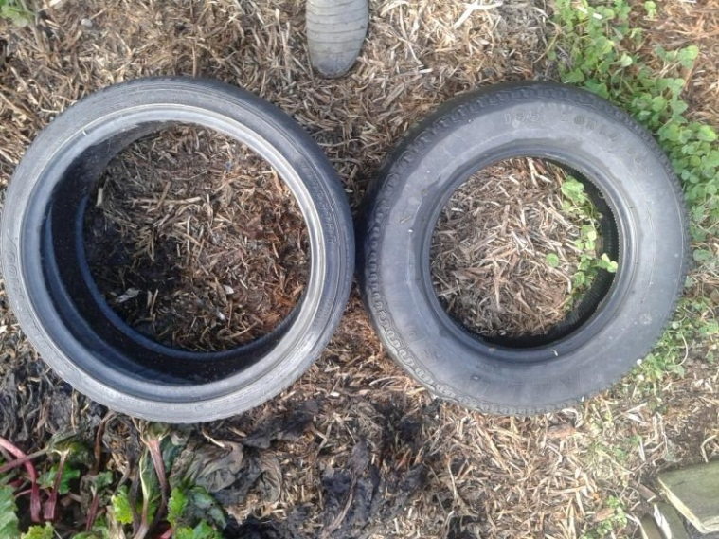
Standard tyre on right, not really useful, boy racer tyre on left – very useful.
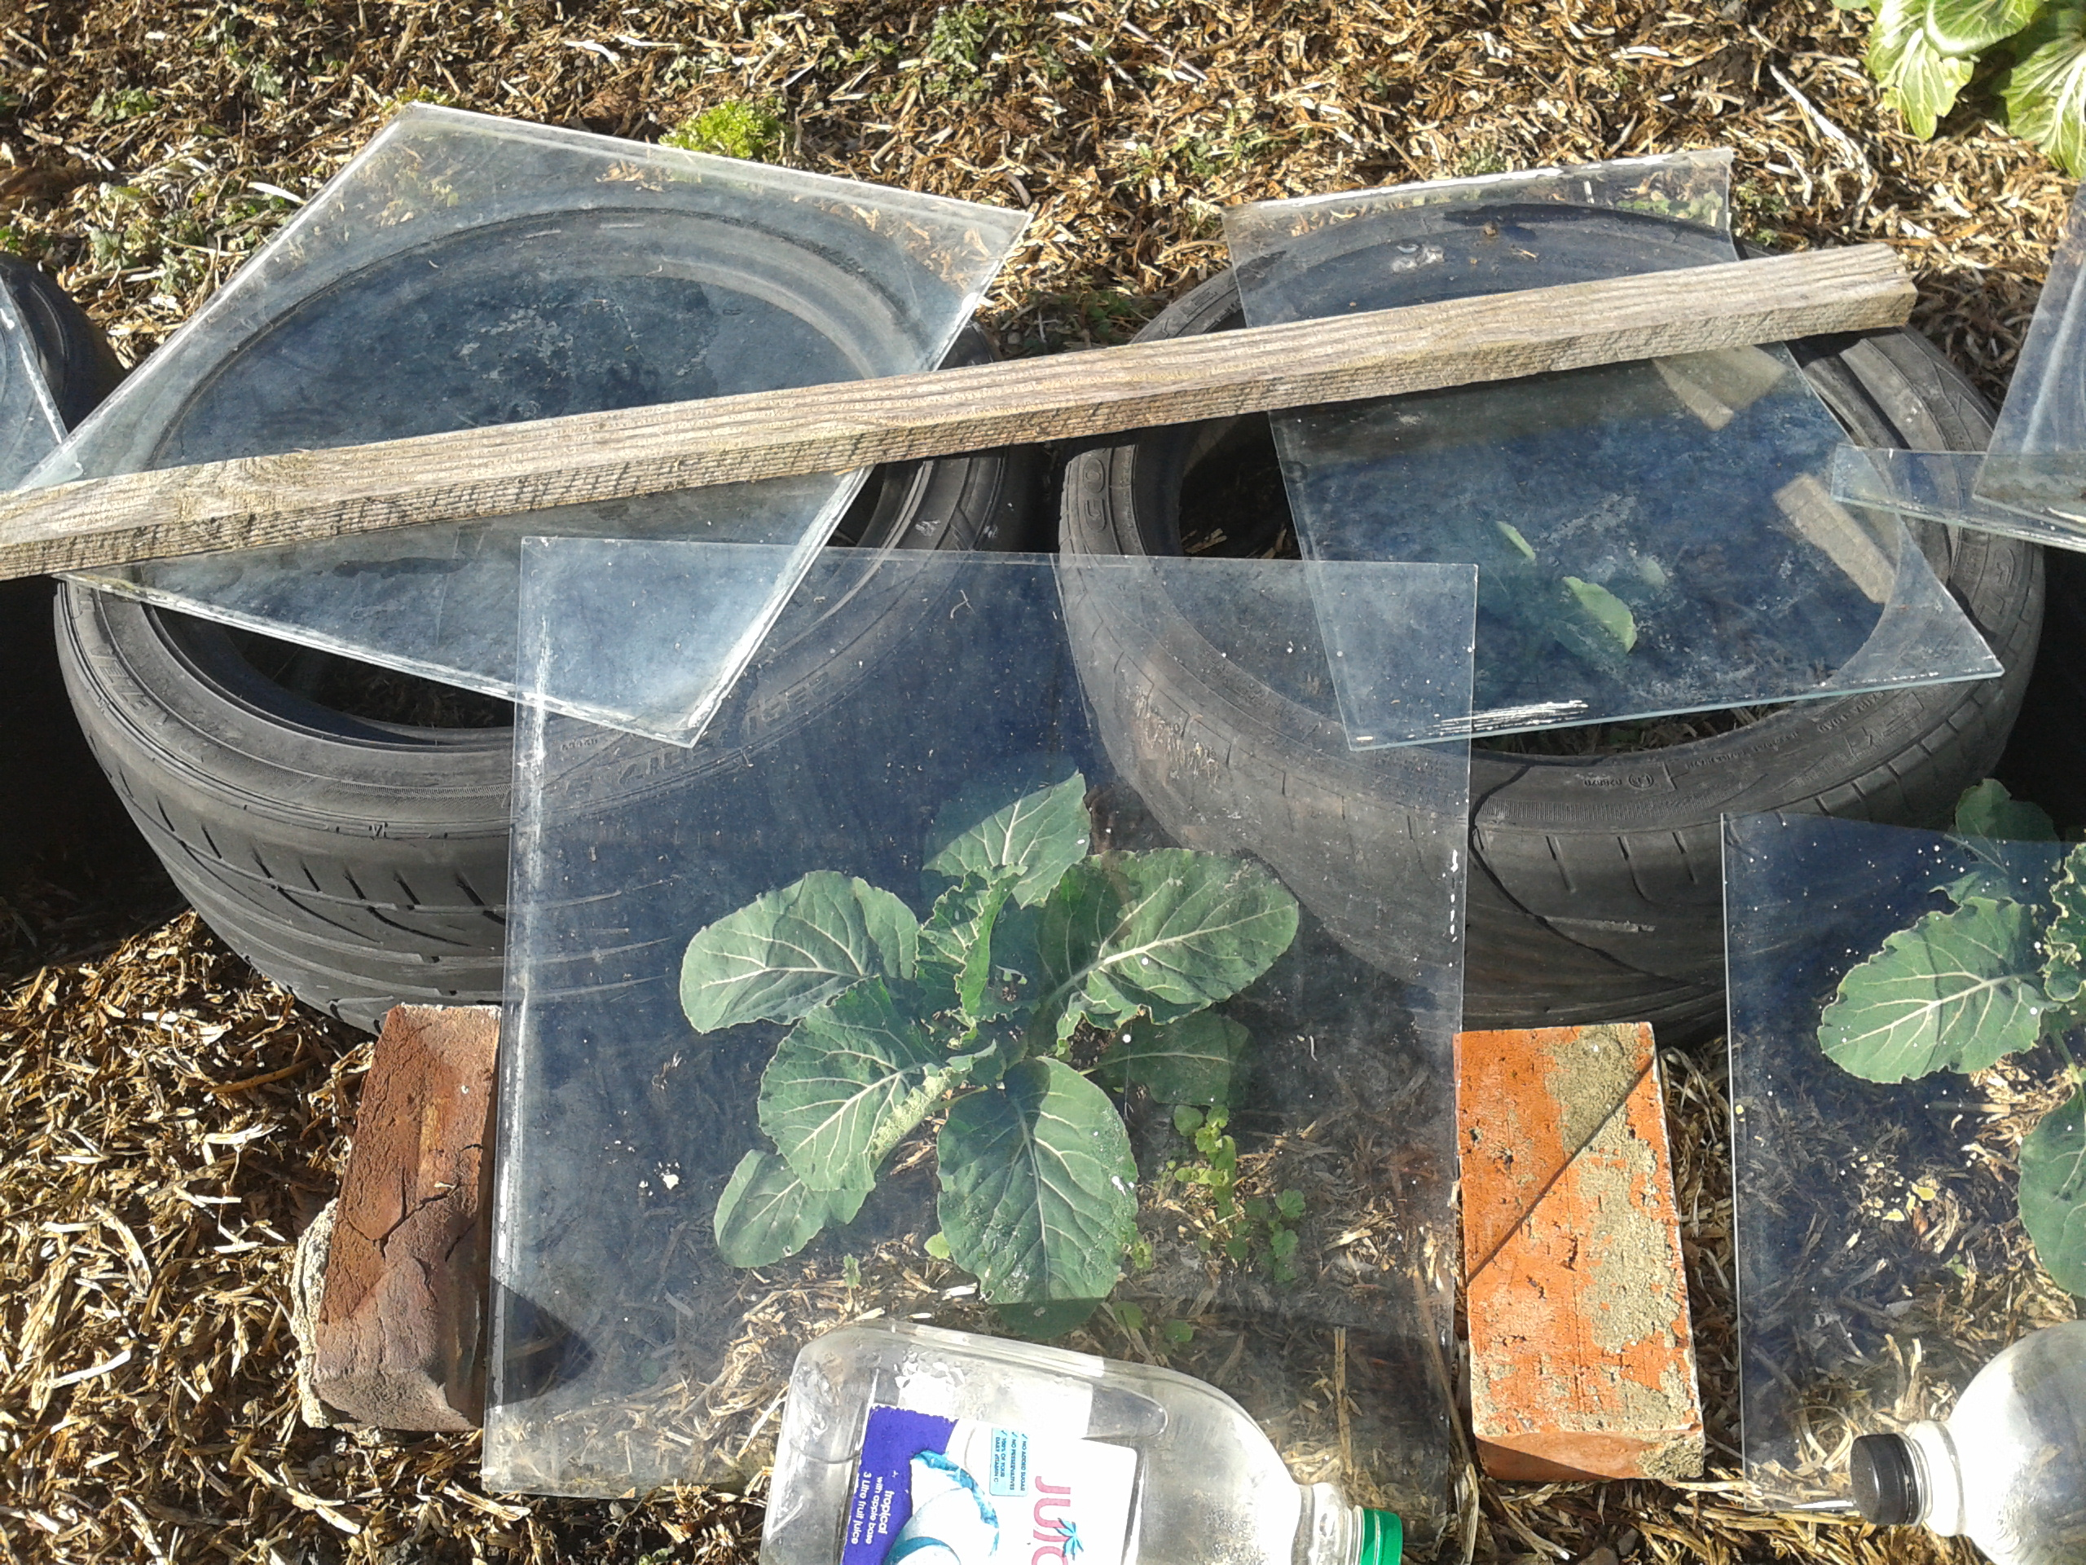
Boy racer tyres work for us in really helpful ways – especially in making compost heaps, and micro glasshouses, rabbit protectors etc. We also store our potatoes in sacks, inside tyres – (we really don’t like green potatoes).

Poultry – Chicken Raising

Getting purpose sorted
There’s some basic questions to answer first. What’s the purpose? Is it
- Enough fresh, rich yolked, free range eggs for your families needs? Probably 2-3 hens will suffice. Anymore and you will probably be donating free eggs to friends, or you need a neighbour who will regularly buy your surplus.
- Eggs to sell at farmer’s markets or roadside? Do a careful budget which will include feed costs, replacement birds every 18 months or so. Don’t forget to factor in mortality. An Uncle who farmed all his life taught me ’if you have live one’s you have dead ones’. There may be costs associated with transporting eggs to whatever market you choose and the opportunity cost of being at the market and not at home, mowing, pruning, digging, creating or relaxing!
- Meat for the table? There are not many of us willing to rear birds, then pluck and dress (yes it’s called dressing – that gutting process) when the commercial guys managing tens of thousands of birds with hundreds of tonnes of feed bought at really sharp prices put meat in supermarket freezers at ridiculous prices. However we put it, those birds have a real crap life, compared to those running truly free. Broiler birds is the name given to birds bred and raised for meat.
- All of the above – sort of! The nice thing with block holding is that you don’t have to have purpose all sewn up neatly. These are your choices.

A word or two about ‘free range’
Don’t con yourself. Free range isn’t really free range if your birds simply have a run that is all dirt and mud depending on whether it rained or not last night! Free range should refer to birds that have access to fresh grass or weeds in areas that are fenced appropriately to keep neighbours dogs out. I’ve always liked the system that has a number of fenced areas so that the birds can range in areas that are green and they can then become the chicken tractor that is written about.

Luckily our hawks seem disinterested in eating our hens, BUT they’ve been known to cart off young chickens.
However you answer the purpose question here’s a series of suggestions with some must haves.

Suggestions
- Start small for the first 6 months.
- Build or buy really good housing – draught free, rat proof is really important.

Must have
- Shelter – house facing into the sun.

http://www.chickensbydesign.co.nz/breeds.php - photos and description of breeds.
An associated website – www.poultrycentral.co.nz is a forum which allows discussion and advice sharing. New to poultry keeping? This is a great place to start and entry simply requires that you agree to their terms of posting and use of material (all reasonable) then you get to ask questions and have other assist you. Your job is to assess the level of competence of those providing advice. That is going to vary considerably. The forum is active with 28,000 posts as of July 2013.

Killing and Meat?
Get a friend over if this is too hard. Even reading these instructions is going to be too much for some of you. Don’t. Get that friend over. Go have a coffee.
Killing chickens can get real messy and it sure isn’t pretty. However it is done, it is crucial that the pain is all over in an instant. Animal welfare is really, really important. I wear old clothes. Take bird in hand, hold by legs, place neck/head on large chopping block, with tomahawk. Chop off head then immediately throw bird under a hedge or shrub. Headless chickens have a name because of what they tend to do. But headless chickens are dead and feel no pain. The old clothes bit, relates to the blood that will squirt out of the neck.
Wringing necks takes some practice. You must feel the neck break. If it isn’t broken it isn’t dead.
Now what? If the bird is an old friend that has laid two or three or more years worth of wonderful eggs, you may be about to bury her with tenderness. But if meat is on your agenda, beware, the meat isn’t going to be real tender. We suggest you turn yourself into a hunter and cut out the breast meat and two legs and you have at least 80% of the meat, without any plucking necessary. You will get a real good chicken casserole, so long as you take time with a slow cook.
I’ve learned a thing or two about composting birds/sheep over the years. It is as simple as three boy racer tyres, in a heap, bird/lamb down the middle, covered with straw, soil, whatever that will join the composting process. You may put a piece of flat iron or plywood over the top to keep flies out. Weight it down, with another tyre. Now dogs and smells are separated. We put these tyre compost systems right near a young fruit tree. They double the growth rate of fruit trees in our infertile soils.

Deleted.

A word about purpose
I look around the parts of New Zealand I’m familiar with. Here’s how I think block holding works.
For a minority the owning of a block is about self sufficiency – the joy of most food, most days, coming from the block or the freezer/drier.
For others it is lifestyle in terms of horses for young and old in the family and all that goes with horses. Wonderful – if so – enjoy.
For others, it seems status that goes with owning a block, pushing neighbours away a little, gaining space and having somewhere to park large lawn…

July 2013 NZ Lifestyle Block magazine.
http://www.wwoof.co.nz/ Willing workers on organic farms NZ.
Useful references used in preparing this section include http://www.deernz.org/productivity-improvement-hub/farm-environment/health-safety/minimising-risks#.UdT7TPl9-ZU http://www.business.govt.nz/healthandsafetygroup/information-guidance/all-guidance-items/agriculture-guidelines-for-the-provision-of-safety-health-and-accommodation-in/agricu-g.pdf 58 pages with many references to further documents. Neate, Graham. May 2013. Managing contractors on your farm. CRT Farmlands Agline p5.
http://farmsafe.co.nz/quad-bike-farm-licence

